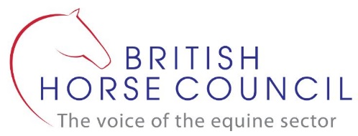
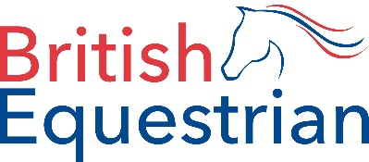

Travelling Horses to the EU post-Brexit – your experiences

If you’ve travelled horses to the EU since 1 January 2021, we want to hear about your experiences of the new protocols and requirements. British Equestrian and the British Horse Council are working on behalf of our member bodies to provide detail to government in a bid in to make improvements to the process.

We are also in regular contact with the International Horse Sport Confederation, which pools the resources and expertise of high-level negotiators in racing and global sport, looking at changes that need to be assessed to minimise the friction and the delays created by the changes.

There is currently a consultation accepting evidence under the Government’s Environment, Food and Rural Affairs Committee, which your case studies can submitted to. You can do this directly or give us permission to do so on your behalf. If you wish to contribute directly, submissions should be made here and must be received by 17 March 2021.

Name:
Contact email:
Contact phone:
Sporting discipline/role:
Journey details
Purpose of journey:
Origin point in the UK:
UK exit port and date of travel:
EU entry port and date of arrival:
Trip duration:
Method of travel across the Channel:
Shipper used:
UK exit port experience:
EU entry port experience:
Pre-travel experience:
(health papers, blood tests, booking BCP, etc. – use all the space you need)
Return journey
EU exit port and date of travel:
UK entry port and date of arrival:
EU exit port experience:
UK entry port experience:
Please give an account of your experiences and the new processes involved: (use all the space you need)
Any other observations, comments or suggestions: (use all the space you need)
I’m happy for my account to be submitted with my name attributed as evidence in any government inquiries/consultations. | Yes | No
I’m happy to be contacted for further info in relation to my travel experience. | Yes | No

Signed:
Date:

Please upload this form once completed to the dedicated Dropbox folder. If you want to provide your own account in a different format, feel free. Photos and videos are welcome.

Remember the deadline for submitting evidence to the government inquiry is 17 March 2021.

